|  |
| --- |
|  |
| ***La Cuisine Restaurant E-Commerce Site and Management with AWS Cloud Infrastructure***  **Engr. Naina Said / Sumaiyya Salahuddin** |
| |  |  |  | | --- | --- | --- | | Muhammad Asif Ayub Assad Ullah Khan | 3/17/20 | Database Management System | |

# Why La Cuisine?

# introductionabstract

# introduction

# Physiological Basisintroductionabstract

# introductionabstract

# introduction

# Physiological Basisintroduction

# Physiological Basis

# ECG FeaturesPhysiological Basisintroduction

# Physiological BasisintroductionWhy La Cuisine?

# introductionabstract

# introduction

# Physiological Basisintroductionabstract

# introductionabstract

La Cuisine Restaurant is our restaurant located in DIKHAN city. La cuisine restaurant is one of the top and oldest restaurants located in DIKHAN which provides the best quality traditional, Chinese and fast foods to the customers for more than 20 years.

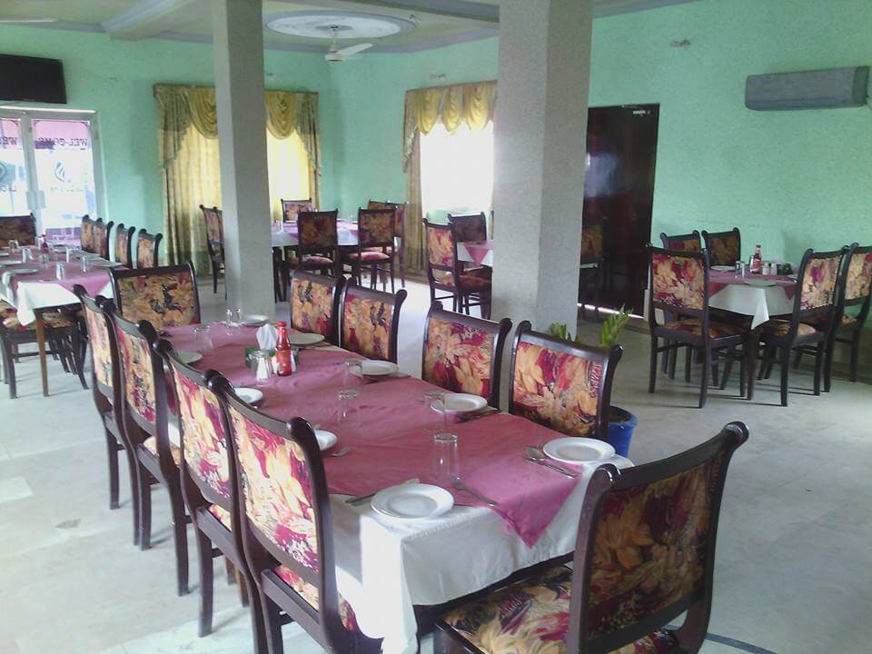In 2018 second quarter, I wanted to upgrade and update the sale and purchase of our restaurant. I have created a social media site because people wanted our restaurant to provide E-commerce services then I decided to create a website with Wordpress that provides E-commerce service in which user can order from our site as well as social media site like Facebook, Instagram, twitter ETC by using a single free plugin named as Gloria food with woo-commerce.

Later on, there was no one to manage the E-commerce system as I was unable to manage it myself cause I was studying in UETP so I decided to make my site down and postponed the online system.

In that complete tenure, I see around a 65% increase in engagements and a 38% increase in selling foods with online delivery.

# introduction

# Physiological Basisintroduction

# Physiological Basis

# ECG FeaturesPhysiological Basisintroduction

# Physiological Basisintroduction

# introduction

# Physiological Basisintroduction

# Physiological Basis

# ECG FeaturesPhysiological Basisintroduction

# Physiological Basisintroduction

This project is not just a front end E-commerce (Online Ordering) site but online Restaurant management system as well that will be implemented using php, mysql, codeigniter, adminlte, bootstrap, jquery, html, css and javascript as well. It is not necessary to link website with the restaurant management system but if we have a time to do this we will try our best to complete this huge project in time.

The administrator can run more than one store on this device. They can monitor every customer, every product, every order and every table based on the shop. The Super Administrator can show anything from every store to every shop. The powers of the users can be handled by the super administrator. The administrator is responsible for the permission of the customer. You will need to configure user permissions for creating, upgrading, displaying, and deleting each module in the system.

Salient Features

# Physiological Basisintroduction

# Physiological Basis

# ECG FeaturesPhysiological Basisintroduction

# Physiological Basisintroduction

**Manage Users**

Add new user detail View, Update, and remove user information

**Manage Groups**

Add new group information View, Update, and remove group information

**Manage Stores**

Add new store data View, Update, and remove store information

**Manage Tables**

Add new table information View, Update, and remove table information

**Manage Category**

Add new category information View, Update, and remove category information

**Manage Products**

Add new product information View, Update, and remove products information

**Manage Orders**

Add new order information View, Update, and remove orders information **Reports**

View total amount of paid orders represented on the graphical chart based on yearly.

View total amount of paid orders represented on the graphical chart based on yearly and store wise.

**Company**

Update the company information That includes company name, address, phone, message, vat charge, service charge and more..

**Profile**

View the logged in user information

**Setting**

View, and Update logged in user information

My website would be fully dynamic that would be hosted on Amazon Web Services by using EC2 instances, Relational Database Systems (Mysql), S3 bucket, Cloudwatch, and many other services, I will provide the Architecture in the end at the implementation stage.

**NOTE:**

These are just pointed features, some of them can be omitted and some new features can be added to this project.

Other things can’t be mentioned in this proposal. With time maybe my project can be modified with new features or omitting the unwanted features.